Department of Economics
P. G. D. A. V. College

A Report on Data Analysis using R
Academic Year 2023-24
- Name of the Event: Online Short-term Certificate Course on ‘Data Analysis using R’
- Date and Time & Duration of Event: 15th September to 6th October 2023, Online sessions for 30 hours were conducted at 4:00-6:00 PM.
- Schedule of Event: Enclosed as Appendix-1
- Details of Guest Speaker/Resource Person: Enclosed as Appendix-2
- Department and Society: Department of Economics and IQAC, PGDAV College
- Name of the Convener and Co-convener with Photograph:
Convener: Dr Rimpy Kaushal
Co-convener: Dr Varun Bhushan
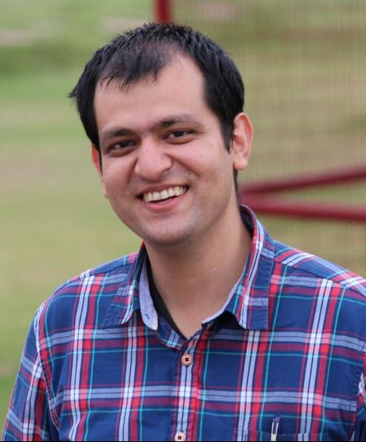
- Name of the Teacher Incharge: Dr Rimpy Kaushal
- Names of Team members:
Prof Krishna Sharma, Principal
Prof Giridhar Gopal Sharma, Director, IQAC
Dr Rimpy Kaushal, Convener
Dr Varun Bhushan, Co-convener
Dr Indranil Chowdhury, Coordinator
Dr Deepika Kandpal
Dr Lalit
Mr Abhinav Parashar
Dr Annu
Ms Anjali Tomar
- Details of Student Coordinators:
Ayushi Khandelwal, B.A. (Hons) Economics Sem-III
Arushi Sharma, B.A. (Hons) Economics Sem-III
Roshani Sharma, B.A. (Hons) Economics Sem-III
Niharika Gupta, B.A. (Hons) Economics Sem-III
Viyom Rana, B.A. (Hons) Economics Sem-III
Koshika Pandey, B.A. (Hons) Economics Sem-V
Gaurika Wahal, B.A. (Hons) Economics Sem-V
Sarth Jain, B.A. (Hons) Economics Sem-V
Raunak Chhabra, B.A. (Hons) Economics Sem-V
Raj Rajeshwari Batra, B.A. (Hons) Economics Sem-V
Princess Verma, B.A. (Hons) Economics Sem-III

- Brief description of the event:
The Department of Economics organised a short-term online course on “Data Analysis using R” for the students, researchers, and faculty members across colleges and universities. This certificate course was designed for beginners who knew nothing about R. We started with the basic knowledge about R and slowly built upon that. We used RStudio, an integrated development environment (IDE) for R. This course helped participants learn R and its use in research in social sciences. Participants learned how to manage large datasets, clean and visualise data, do econometric and statistical analysis of datasets.
We received an overwhelming response from the academic fraternity this year with two hundred twenty nine (229) registrations from reputed institutions of the country including, XLRI Jamshedpur, IIT Hyderabad, Indian Institute of Foreign Trade, Banaras Hindu University, Aligarh Muslim University, NIPFP, Central University of Punjab, Central University of Tamil Nadu, Central University of Jammu, University of Rajasthan, University of Hyderabad, and many others. The course was attended by 32 faculty members, and 197 students and research scholars from various colleges, universities, and institutions of the country. After successful completion 16 faculty members, 31 research scholars, and 101 students were awarded with certificates. Lists of total registered participants (Appendix-3) and successful participants (Appendix-4) have been attached.
The certificate course was of 30 hours duration. There were 2 hours of live online sessions every day for 15 days over Zoom. The sessions were held from 15 September 2023 to 6 October 2023. The inaugural session was addressed by Mr. Indranath Mukherjee, Vice-President, Analytics AXA XL.
- Mode of event: Online
- Details of participants: Enclosed as Appendix-3
- Details of Successful Participants: Enclosed as Appendix-4
- Valedictory
The course was concluded with an interactive discussion between Mr. Sanjeev Bikhchandani, the Founder and CEO of Naukri.com and Prof Ashwani Mahajan in the valedictory session. Dr Geeta Kalucha, Associate Professor from Department of Mathematics and Arjit Thakur, student of Motilal Nehru College shared their experiences about the course in the valedictory session.
- Drive link with the photographs of the events:
https://drive.google.com/drive/folders/11M-SIq_zr1VG6PDNMidqcW-sgmMxhw9G?usp=share_link

